7th Grade Unit 4: Restless Earth

Lesson 1: What are Earth’s layers?
Vocab: crust, mantle, convection, core, lithosphere, asthenosphere, mesosphere

3 layers based on chemical composition:
- Core- form the mantle to the center of Earth
  - Mostly made of iron and some nickel
  - May have some oxygen, silicon, aluminum, magnesium
  - The densest layer
  - ⅓ of Earth’s mass
  - Mantle- located between the core and the crust
    - Region of hot flowing rock
    - Convection currents happen here
    - Convection- movement of matter caused by temperature differences
    - Warm matter rises b/c it is less dense and cool matter falls b/c it is more dense
    - Made of larger amounts of magnesium and aluminum
- Crust- the solid outermost layer of Earth
  - 2 types: continental (land) and oceanic (under oceans)
  - Both types are mostly oxygen, silicon, and aluminum
  - The oceanic crust is more dense and has 2x the iron, calcium, and magnesium
- aka. Compositional layer
Physical layers are defined by their physical properties (state of matter, temp. etc.)
- Inner core
  - Solid and the most dense
  - Center of the Earth is 6,380 km below the crust
- Outer core
  - Liquid outer layer of the core
- Mesosphere
  - Lower part of the mantle
  - Rock flows more slowly here than in the asthenosphere
- Asthenosphere
  - Layer of weak or soft mantle made of rock that flows slowly
  - Tectonic plates move on this layer
- Lithosphere
  - Outermost rigid layer; solid rock
  - Divided into tectonic plates
  - Made of 2 parts the rigid upper mantle and the crust
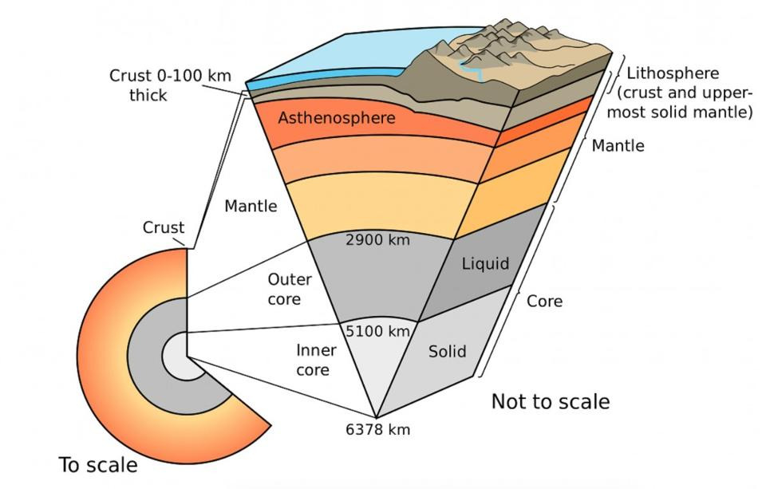

Lesson 2: What is plate tectonics?
Vocab: Pangea, sea-floor spreading, plate tectonics, tectonic plates,
convergent boundaries, divergent boundaries, transform boundaries, convection

Evidence for Continental drift or the continents moving
- Continents look like puzzle pieces that should fit together
- Fossils of the same species are found on continents on different side of the Atlantic ocean (species that could not have crossed an ocean)
- Locations of mt. ranges and rock formations
- Sedimentary rock evidence of climate conditions on several continents (plants in Antarctica)

Pangea- a supercontinent that existed 245 MYA
- During the time of Pangea there was only one ocean, Panthalassa
- 200 MYA a rift formed and created 2 continents, Laurasia and Gondwana
- Drifted further apart forming the Atlantic ocean 150 MYA
- Continents collided into other continents creating mt. ranges

Discoveries that supported Alfred Wegener’s idea
- Harry Hess mapping the ocean floor; discovered the mid-Atlantic ridge
- Led to the theory of plate tectonics
- Rock samples from the mid-Atlantic ridge show that youngest rocks are near the crack and the oldest are nearest the continents on either side
- The rocks show magnetic patterns that are mirror images on either side
- Sea-floor spreading- process where molten rock is rising to the crack/ridge where it cools to form new oceanic crust
  - As the sea floor moves and expands the continents move
- Ocean trenches are places where oceanic crust is going under continental crust and back into the mantle
  - Oldest rock is pushed under the continent and recycled
  - This conveyor belt of rock is why rock is being made but Earth doesn’t get any bigger
Plate tectonics- describe the large scale movement of the Earth’s lithosphere, which is broken into plates (tectonic plates)
- Plates move on the asthenosphere
- Ex. N. American, Nazca, S. American, African, Australian, Eurasian, Indian, Antarctic, Pacific
- Some have continent and ocean some only have one type
- Ocean plate is more dense than continent so it will sink down 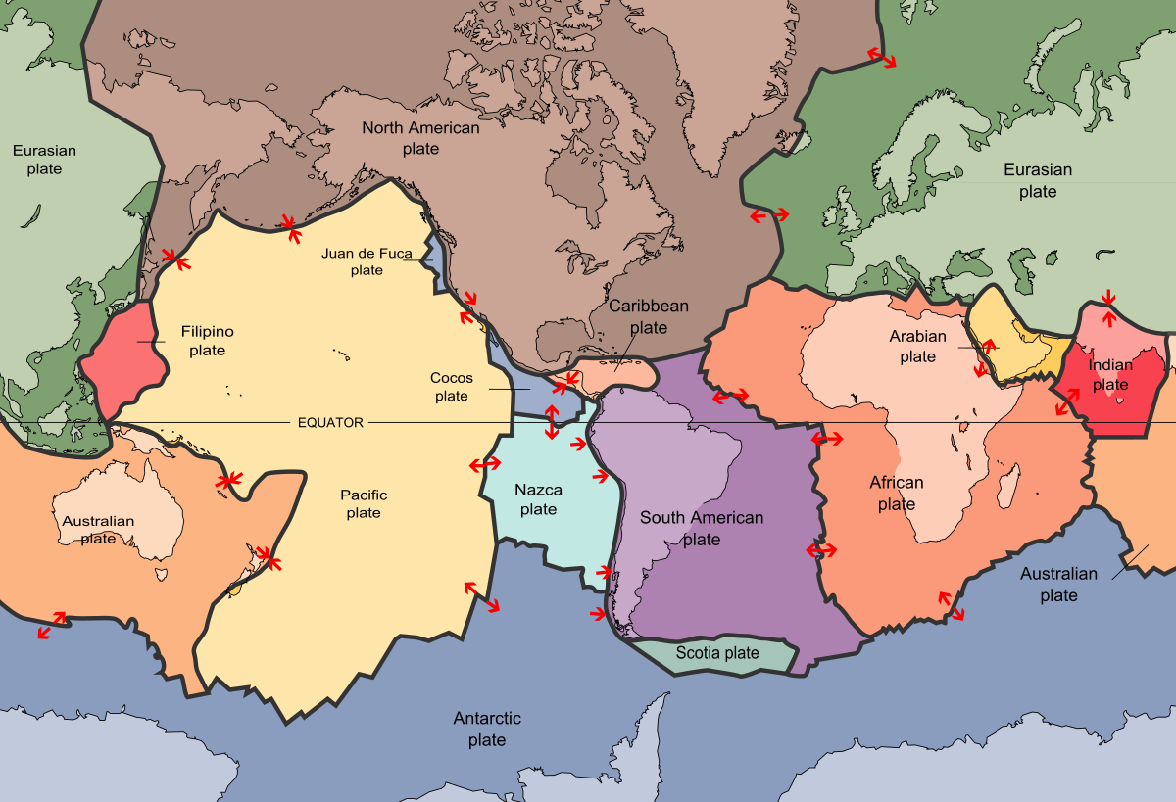

3 types of boundaries

Convergent boundaries- area where 2 plates push together (collide)
- 3 types
- Continent to continent- very thick plates buckle and thicken to create mountains
- Ocean- to continent- thin dense oceanic plate is forced under thick less dense continental plate creates a subduction zone; volcanoes occur here due to hot spots caused by friction
- Ocean to ocean- the older denser plate will go under the younger less dense plate; creates archipelagos or chains of volcanic islands (ex. Hawaii and Japan)
- 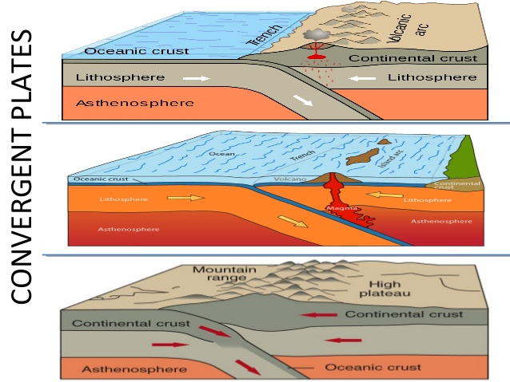
Divergent boundaries- two plates that pull away from each other
- Allows the asthenosphere to rise up creating lava that then makes new rock
- Creates ocean ridges (raised area around the crack); mid-Atlantic ridge
- Creates a rift valley on land; the Great Rift Valley in Africa
Transform boundaries- two plates move past each other horizontally
- Causes earthquakes when the built up energy finally slips
- Ex. San Andreas fault in CA between the Pacific plate and the N. Amer. plate
- Short segments of other boundaries connected by transform faults are called fracture zones
Causes of plate movement
- 3 ideas for how it happens
  - Mantle convection-hot rock rising and cool rock sinking back towards the core
  - Ridge push- gravity causing new rock at the ridge to push old rock away from the ridge
  - Slab pull- at subduction zone the dense rock going down pulls the rest with it
  - 